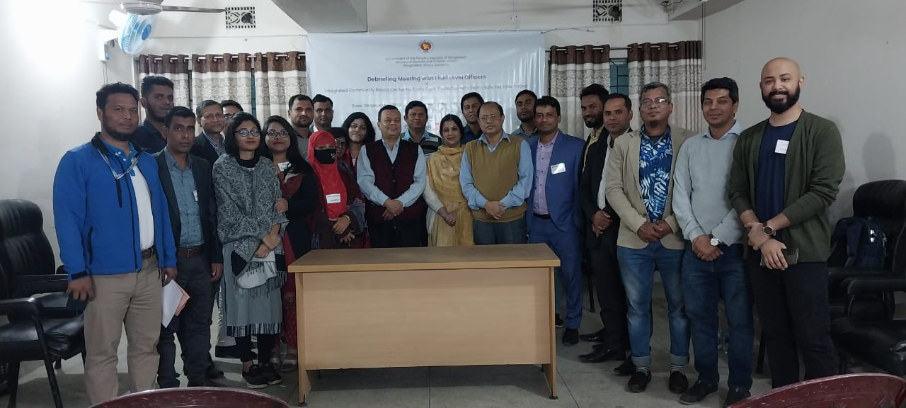
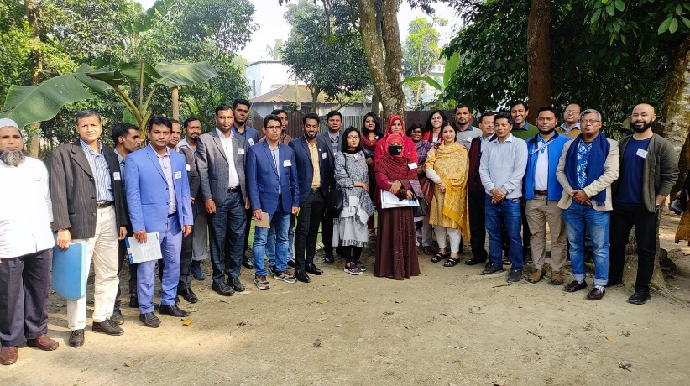
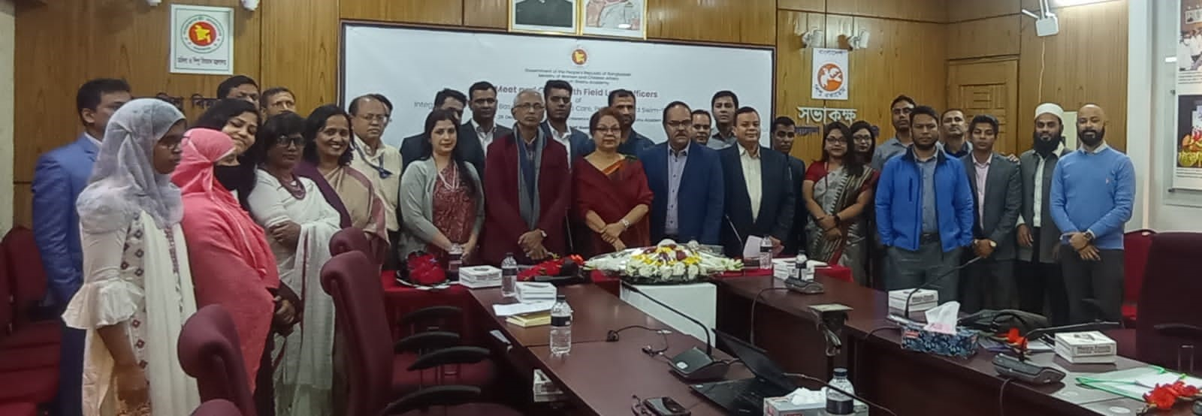Recently, on 28 December 2022, the newly recruited Assistant Program Managers (APMs) of the ICBC project, gathered together for a meet and greet with Ms. Lucky Enam, Chairman, Bangladesh Shishu Academy, Anjir Liton, Director General, Bangladesh Shishu Academy and Most. Ferdousi Begum, Project Director (additional charge) of ICBC project at Bangladesh Shishu Academy along with the Mr. Md. Tariqul Islam Chowdhury, Program Manager, ICBC project and members of technical partners Synergos, CIPRB and BRAC IED.

The next day, on 29 December 2022, the team of APMs were taken for a field visit to Monohardi, Narshingdhi, to see Child Care Center and Swim Safe activities of CIPRB sites that are soon to be taken over by BSA.
The APMs were all very eager to start the learning journeys in their new and exciting positions in 16 different districts of the country.

